Enter your name and address in the space below

*****
*****
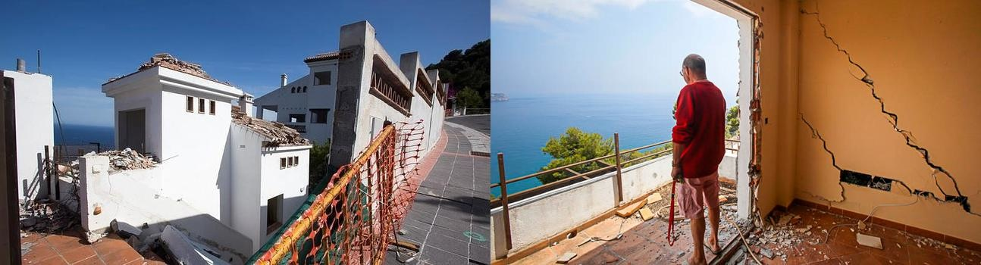
*****
*****

As a member of your constituency, I ask for your help with a problem that affects many hundreds of EU citizens. I am the owner of a house in Carmenes del Mar La Herradura on the south coast of Spain. Between 2001-2005 416 houses were completed and sold. Cracked walls, pavements and roads buckled before completion of the final phase. It was obvious the entire urbanisation was affected by very serious structural problems.

A geological study in 2007 confirmed the building techniques used in construction were inadequate and there was a pre-existing tendency to landslides on the hillside making the location unsuitable. The report showed that a proper geological survey had not been carried out, either by the promoter who built and sold the properties, or by the town planners and engineers who approved and issued licenses to build. It was known in advance that the land was unsuited to large scale development, yet building went ahead. 416 unsuspecting people bought into a nightmare that is unfolding today.

Since 2007, houses have fallen down, people have been evicted. Many of us have mortgages and tax bills on properties that are uninhabitable, insurance companies won’t pay out, the urbanisation continues to deteriorate at an alarming rate. Each year when the rains come we fear the worst!! Our cause has received much media coverage see: www.carmenesdelmar.com and www.savecarmenesdelmar.com

A legal Class Action against the wrong doers will be followed by appeal after appeal. The earliest we can hope for a final ruling is 2020. By then it will be too late. Remedial action can avert further problems as has been proved elsewhere. However we feel abandoned by a system that offers us no protection and fails to uphold our rights. We the owners are turning now to the European Parliament and you our MEPs for help and protection from ruin and heartbreak.

Please contact, on my behalf, the Spanish authorities listed below, convey your concern asking them to use their best efforts to find a practical solution to our problem.I am very grateful for your time and interest. A letter from our MEP will give us renewed hope to carry on!

Yours sincerely

ENTER YOUR NAME HERE
…………………………………..

MEPS - please write to these individuals

Snr. D. José Manuel Garcia Margallo Snra. Susanna Diaz
Ministro de Asuntos Exteriores Presidente de la Junta de Andalucia
de España Avenida de Roma S/N
C/ C/Juan de Mena, 4 Palacio de San Telmo
28071 Madrid 41004 Sevilla
Spain Spain

Snr. D. Antonio Germán Beteta Barreda
Secretario de Estado de Administraciones Públicas
Mº de Hacienda y Administraciones Públicas
C/ Alcalá 9
28071 Madrid
Spain

